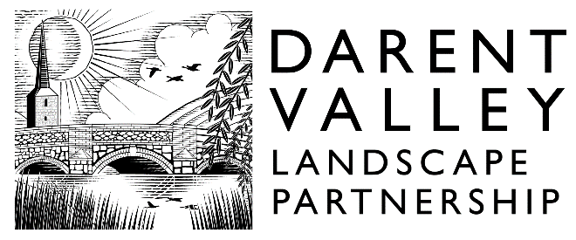

DARENT VALLEY LANDSCAPE PARTNERSHIP SCHEME

LANDSCAPE & HERITAGE GRANTS

LANDSCAPE & HERITAGE GRANTS APPLICATION

Expression of Interest Form

Grants available in the scheme area between £1,000 and £15,000

Before filling in this application form please ensure that you read the Introduction and Guidance and other guidance documents that can be found on the grants pages of the Darent Valley Landscape Partnership website (www. darent-valley.org.uk) or can be obtained from:

Darent Valley Landscape Partnership Scheme
The Tea Barn
Castle Farm, Redmans Lane
Shoreham, Kent
TN14 7UB

T. 01732 280951
E. tim.owen@kentdowns.org.uk
W. darent-valley.org.uk

LANDSCAPE & HERITAGE GRANTS
Title of the project

Organisation name

Contact Name

E-mail

Organisation Street Address including building name and number, Town, County and Post Code

Project start date

Project end date

Estimated total project cost

How much funding are you applying for (see guidelines for details on funding levels)

How will you fund the remaining element of the project costs (match funds can include in-kind contributions such as volunteer hours and pro-bono work)

Where will the project take place? (Site name, address and/or grid reference)

If you are not the landowner, do you have written consent from the landowner(s) to carry out this project?

Project Summary (briefly summarise what you are planning to do, the project's main outcomes and how will you publicise and acknowledge your grant?)

Please return the completed form to:
Darent Valley Landscape Partnership Scheme
The Tea Barn
Castle Farm, Redmans Lane
Shoreham, Kent
TN14 7UB
or email to:
tim.owen@kentdowns.org.uk

